# theSource CIF – MED D EGWP

CIF

Client Information

Client Specific Process

Call Type Handling Grid

Need to Know

Open/Annual Enrollment Period

Enrollment/Disenrollment

Eligibility

Coordination of Benefits

Premium Billing

Fulfillment

Retail Logic

Plan Design Highlights

Specialty Plan Design Highlights

Overrides

Coverage Determination

Appeals Process

Paper Claims

Client Program & Offerings

Grievances

Fraud, Waste and Abuse

Related Content

**Description:** This job aid provides information about how the CIF displays in theSource.

|  |
| --- |
| CIF |

 **Not all sections/categories apply to all clients. theSource only shows sections or categories relevant to the client.**

**Reminder:** Use CTRL+F to find key words if having trouble locating a specific topic.

The screen displays all the CIF sections in the Collapsed view. Clicking the down arrows to the right of each section expands the details.

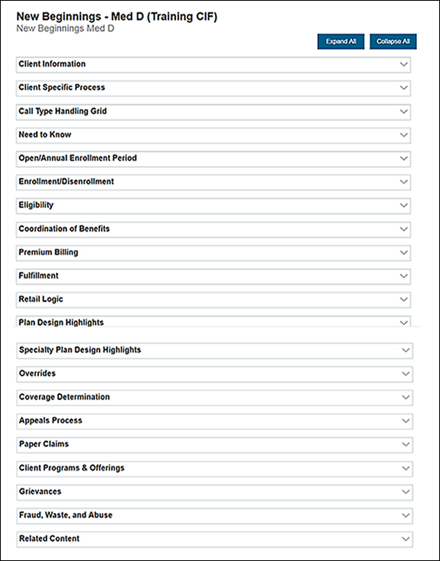

Top of the Document

|  |
| --- |
| Client Information |

The Client Information section provides an overview of key information about the client:

* Client Line of Business
* Client Customer Care Number
* Pharmacy Help Desk Number

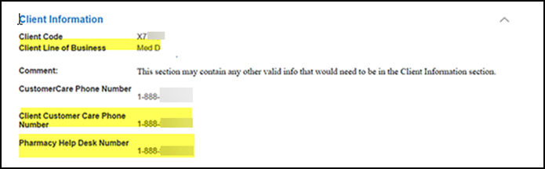

Top of the Document

|  |
| --- |
| Client Specific Process |

The Client Specific Process section details the key plan options that the client has in place:

* Bridge Supply
* Bulk Up
* DAW5
* Fill & Bill
* Mail Tags

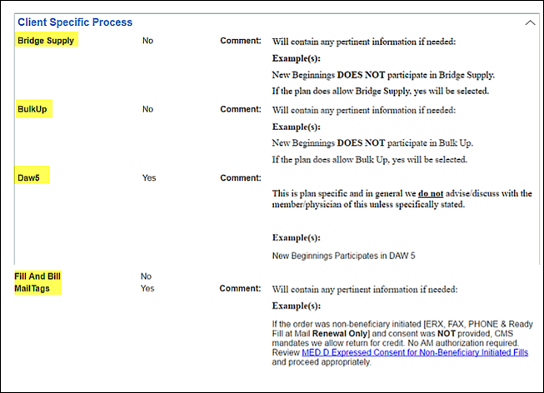

Top of the Document

|  |
| --- |
| Call Type Handling Grid |

The Call Type Handling Grid section contains detailed instructions on which call types Caremark handles and which call types the client and/or other client’s vendor handles.

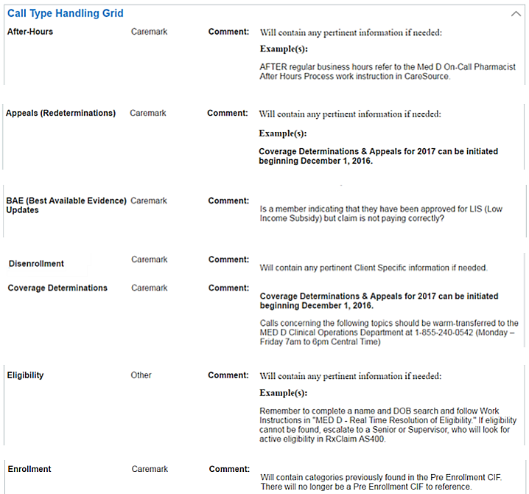

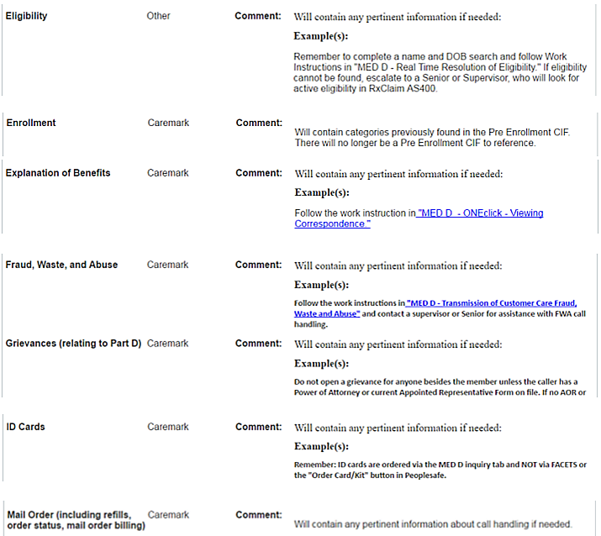

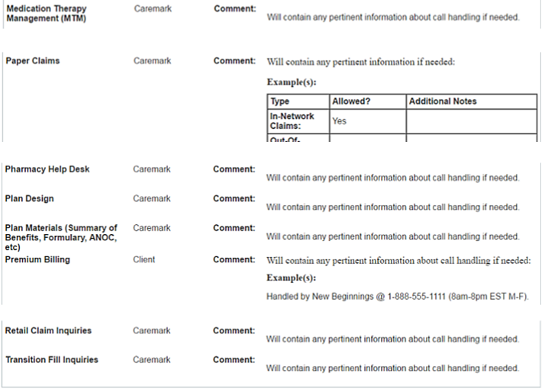

Top of the Document

|  |
| --- |
| Need to Know |

The Need to Know section is where you will find items that do not have a section of their own or is an immediate “need to know” item.

Top of the Document

|  |
| --- |
| Open/Annual Enrollment Period |

The Open/Annual Enrollment Period section contains specific information on how to handle certain call types during the Open/Annual Enrollment period.

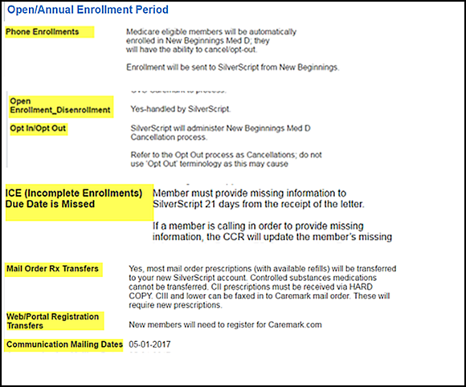

Top of the Document

|  |
| --- |
| Enrollment/Disenrollment |

The Enrollment/Disenrollment section contains specific client information about how to handle enrollment and disenrollment inquiries.

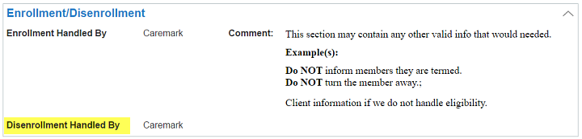

Top of the Document

|  |
| --- |
| Eligibility |

The Eligibility section contains information about how the client’s eligibility is set up and includes the Best Available Evidence category.

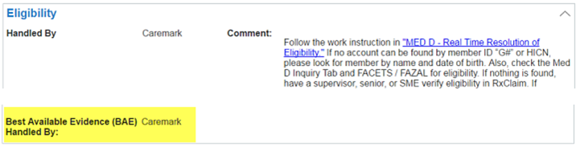

Top of the Document

|  |
| --- |
| Coordination of Benefits |

The Coordination of Benefits section contains details about how the plan handles COB requests and includes categories for Secondary Payer and SPAP.

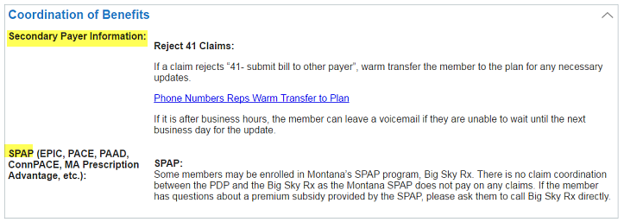

Top of the Document

|  |
| --- |
| Premium Billing |

The Premium Billing section contains specific information about who handles Premium Billing for the client and includes categories for IRMAA and LEP.

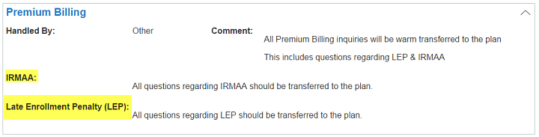

Top of the Document

|  |
| --- |
| Fulfillment |

The Fulfillment section contains information about who handles ID card mails, if the client participates in the ExtraCare Health Card program and who sends EOBs.

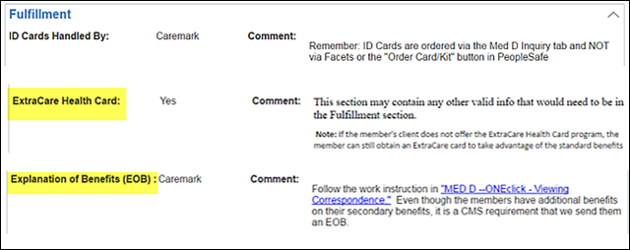

Top of the Document

|  |
| --- |
| Retail Logic |

The Retail Logic section outlines the components necessary to process a claim, including:

* COB
* Reject 41 Secondary Payer Change Handled By
* Pharmacy Notifications Implementation

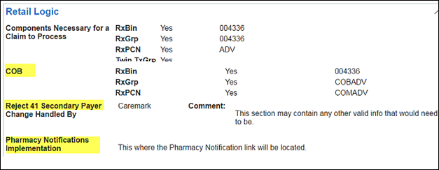

Top of the Document

|  |
| --- |
| Plan Design Highlights |

The Plan Design section outlines key elements of the client’s plan design:

* B vs D Determination
* DAW Drug Rules
* DAW Waiver
* Fill Limitations/Refill Restrictions (changed from Refill Restrictions)
* Flexible Copay Incentive (moved from Programs & Offerings section)
* Medicare Part B
* OTC Benefits
* Step Therapy (moved from Programs & Offerings section)
* Vaccine Information

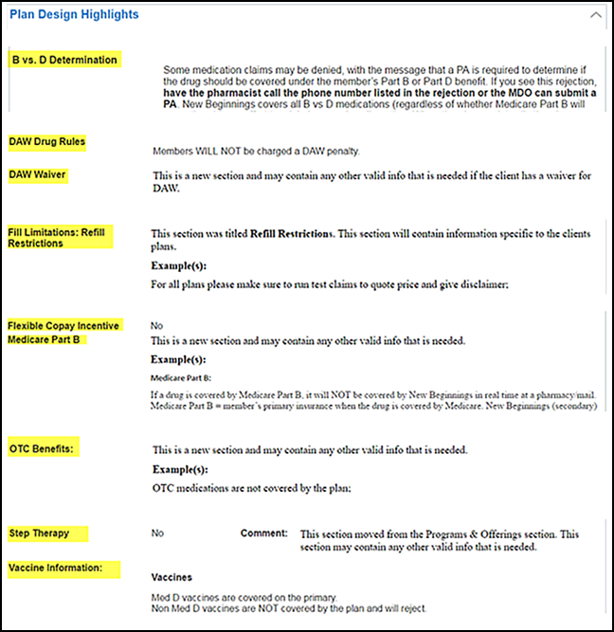

Top of the Document

|  |
| --- |
| Specialty Plan Design Highlights |

The Specialty Plan Design Highlights section provides information on key aspects of the client’s specialty offerings.

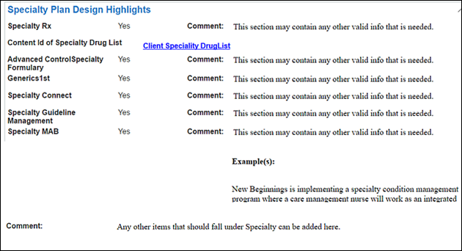

Top of the Document

|  |
| --- |
| Overrides |

The Overrides section contains the information on which overrides are allowed by the plan.

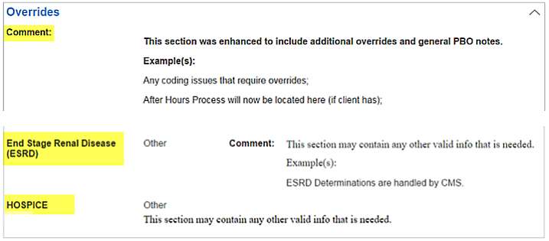

Top of the Document

|  |
| --- |
| Coverage Determination |

The Coverage Determination section contains specific information on how to handle Coverage Determination requests and after-hours processes, as well as a MedHOK Effective Date category for the client.

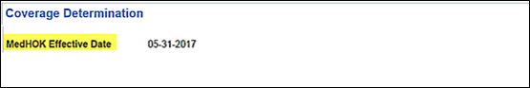

Top of the Document

|  |
| --- |
| Appeals Process |

The Appeal Process section provides information about who the appeals processor is and the various levels of appeal available to members.

Top of the Document

|  |
| --- |
| Paper Claims |

The Paper Claims section provides a comprehensive list of the various types of paper claims allowed by the plan.

Top of the Document

|  |
| --- |
| Client Program & Offerings |

This section outlines the Client Programs and Offerings available to members.

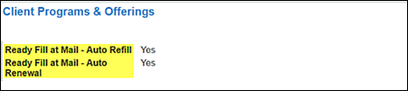

Top of the Document

|  |
| --- |
| Grievances |

The Grievance section contains details about who handles submitting a Grievance and any client specific instructions or sensitivities about how to handle them.

Top of the Document

|  |
| --- |
| Fraud, Waste and Abuse |

The Fraud, Waste, and Abuse section contains details about who handles FWA claims and instructions on how to process FWA issues.

Top of the Document

|  |
| --- |
| Related Content |

This section provides links to related content (samples) for the client, such as Job Aids, Drug List, Matrices, etc.

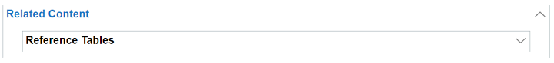

Top of the Document

Not To Be Reproduced Or Disclosed to Others Without Prior Written Approval

**ELECTRONIC DATA = OFFICIAL VERSION – PAPER COPY – INFORMATIONAL ONLY**